CERTIFICATE OF INSTALLATION
This Certificate of Installation documents the installation of mechanical features, materials, components, and manufactured devices required to demonstrate compliance with Title 24, Part 6 per §10-103(a)3 for nonresidential, hotel/motel and high-rise residential occupancies.
Project Name: | Enforcement Agency:
Dwelling Address: | Permit Number:
City and Zip Code: | Date Permit Issued:

A. GENERAL INFORMATION
01 | Project Location (city): |  | 02 | Zip Code:
03 | Date of Permit Set used for construction: |  | 04 | Name of Permit Set used for construction:
05 | Authority Having Jurisdiction: |  | 06 | Building Permit #:
07 | Date of As-built Set: |  | 08 | Name of As-built Set:

B. INSTALLER SCOPE
This table indicates construction systems and materials documented on this Certificate of Installation.
01
□ | Dry System (Airside) Equipment | □ | Ventilation | □ | System Controls | □ | Ductwork
□ | Boiler | □ | Pumps | □ | Terminal Box Controls | □ | Piping
□ | Chiller | □ | Fans and Air Economizers | □ | Heat Rejection Equipment (cooling towers, condensers, waterside economizers) | □ | Electric Resistance Heating

C. COMPLIANCE RESULTS
This table indicates whether the as-built conditions documented in this form are equal or better than what was documented on the permitted Certificate of Compliance. If the installation is not equal or better, Section 10-103(a)2B requires the Certificate of Compliance form to be revised accordingly to demonstrate compliance.
01 | INSTALLED FEATURES EXACTLY MATCH DESIGN ON PERMITTED CERTIFICATE OF COMPLIANCE
Documented as-built conditions should be verified by inspector from Authority Having Jurisdiction to comply.
The Certificate of Compliance should be revised to confirm as-built conditions comply and this Certificate of Installation updated accordingly.

D. EXCEPTIONAL CONDITIONS
This table is auto-filled with uneditable comments because of field conditions noted by the installer that may impact requirements documented on the Certificate of Compliance.

E. INSTALLER NOTES
This table includes remarks made by the installer to the Authority Having Jurisdiction.

F. INSTALLATION DETAILS
The following tables indicate performance requirements as documented on the permitted Certificate of Compliance for all systems and components included in Table B. Installer Scope. Also indicated are the as-built conditions documented by the installer/ documentation author.

Dry System Equipment Schedule
01 |  | 02 | 03 | 04 | 05 | 06 | 07 | 08 | 09 | 10 | 11 | 12 | 13
Name or Item Tag |  | Model # | Equipment Type | Heating Mode |  |  |  | Cooling Mode |  |  |  |  | Equipment Compliance
 |  |  |  | Rated Output  (kBtu/h) | Supplemental Heating Output  (kBtu/h) | Efficiency | Efficiency Unit | Rated Output  (kBtu/h) | Efficiency | Efficiency Unit | Efficiency | Efficiency Unit
Per C of C
As-built Conditions

Heat Pump Equipment Schedule
01 |  | 02 | 03 | 04 | 05 | 06 | 07 | 08 | 09 | 10 | 11 | 12 | 13
Name or Item Tag |  | Model # | Heating Mode |  |  |  | Cooling Mode |  |  |  |  |  | Equipment Compliance
 |  |  | System Category | Size Category  (Btu/h) | Efficiency | Efficiency Unit | System Category | Size Category  (Btu/h) | Efficiency | Efficiency Unit | Efficiency | Efficiency Unit
Per C of C
As-built Conditions

DX DOAS Schedule
01 |  | 02 | 03 | 04 | 05 | 06 | 07 | 08 | 09 | 10
Name or Item Tag |  | Model # | Equipment Type | Energy Recovery | Rating Condition | Efficiency | Efficiency Unit | Efficiency | Efficiency Unit | Equipment Compliance
Per C of C |  |  |  |  |  |  | ISMRE |  | ISCOP
As-built Conditions

Boiler Efficiency and Controls
01 |  | 02 | 03 | 04 | 05 | 06 | 07 | 08 | 09 | 10
Tag/Plan Detail ID |  | Model # | Equipment Type | Quantity | Rated Input  (Btu/h) | Rated Efficiency | Efficiency Unit | Controls |  | Equipment Compliance
 |  |  |  |  |  |  |  | Isolation Valve | Temperature Reset
Per C of C
As-built Conditions

Chiller Efficiency and Controls
01 |  | 02 | 03 | 04 | 05 | 06 | 07 | 08 | 09 | 10 | 11 | 12
Tag/Plan Detail ID |  | Model # | Equipment Type | Quantity | Size  (tons) | Rated Efficiency #1 | Efficiency Unit #1 | Rated Efficiency #2 | Efficiency Unit #2 | Controls |  | Equipment Compliance
 |  |  |  |  |  |  |  |  |  | Isolation Valve | Temperature Reset
Per C of C
As-built Conditions

Heat Rejection Equipment (Cooling Towers, Condensers, Waterside Economizers) Efficiency and Controls
01 |  | 02 | 03 | 04 | 05 | 06 | 07 | 08 | 09 | 10 | 11 | 12
Tag/Plan Detail ID |  | Model # | Equipment Type | Quantity | Rated Performance | Performance Unit | Controls |  |  |  |  | Equipment Compliance
 |  |  |  |  |  |  | Fan Speed Control | Tower Flow Turndown | Fan Control in Multiple Cell Equipment | Economizer Control | Condenser Water Temp. Reset
Per C of C
As-built Conditions

Electric Resistance Heating
01 |  | 02 | 03 | 04 | 05
Name or Tag ID |  | Model # | Equipment Description | Output Capacity  (kW) | Equipment Compliance
Per C of C
As-built Conditions

Pumps
01 |  | 02 | 03 | 04 | 05 | 06 | 07 | 08 | 09
Name or Tag ID |  | Type | Quantity | Horsepower  (HP) | Controls |  |  |  | Equipment Compliance
 |  |  |  |  | Variable Flow Controls | Hydronic Heat Pump Isolation | VSD on Pumps > 5HP | Differential Pressure Sensor
Per C of C
As-built Conditions

Fans and Air Economizers
01 |  | 02 | 03 | 04 | 05 | 06
Name or Tag ID |  | Quantity | Fan Function | Economizer | Fan Electrical Input Power  (W) | System Compliance
Per C of C
As-built Conditions

Dedicated Outdoor Air System (DOAS)
01 |  | 02 | 03 | 04 | 05 | 06 | 07
System Name |  | Quantity | Delivered Directly To The Space | DOAS Fan Control | Multi-Zone DOAS with Cooling | Multifamily DOAS | System Compliance
Per C of C
As-built Conditions

H. Fan Energy Index (FEI)
01 |  | 02 | 03 | 04
Fan System Name or Item Tag |  | Name or Item Tag | FEI Exception | FEI
Per C of C
As-built Conditions

Exhaust Air Heat Recovery
01 |  | 02 | 03 | 04 | 05 | 06 | 07
Fan System Name |  | Required? | Type of Heat Recovery Rating | Required Recovery Ratio | Installed Recovery Ratio | Energy Recovery Bypass | System Compliance
Per C of C |  |  |  |  | NA
As-built Conditions

Dwelling Unit Fan Efficacy & Energy/Heat Recovery
01 |  | 02 | 03 | 04 | 05 | 06 | 07
Fan System Name or Item Tag |  | System Airflow  (cfm) | Input Power  (kW) | Watts/CFM | Energy/Heat Recovery Ventilation | Sensible Recovery/Effectiveness | System Compliance
Per C of C
As-built Conditions

System Controls
01 |  | 02 | 03 | 04 | 05 | 06 | 07 | 08 | 09
System Name |  | Thermostats | Shut-Off Controls | Isolation Zone Controls | Demand Response | Supply Air Temp. Reset | Window Interlocks | Direct Digital Control (DDC) | System Compliance
Per C of C
As-built Conditions

Nonresidential, Hotel/Motel and Multifamily Common Use Ventilation Systems
01 |  | 02 | 03 | 04
System Name |  | System Design OA CFM Airflow | System Design Transfer Air CFM | Air Filtration
05 |  | 06 | 07 |  | 08 | 09
Space Name |  | Exhaust Ventilation | Occupant Sensor Controls |  | Demand Control Ventilation | System Compliance
Per C of C
As-built Conditions

Multifamily Dwelling Unit Ventilation Systems
01 |  | 02 | 03 | 04 | 05 | 06 | 07
Space Name |  | Outside Air  CFM | Supply Air  CFM | Exhaust  CFM | Local Exhaust | Air Filtration | Space Compliance
Per C of C
As-built Conditions

Terminal Box Controls
01 |  | 02 | 03 | 04 | 05 | 06 | 07 | 08 | 09
Zone/System/VAV Box Name or Item Tag |  | Zonal Control Strategy | Design |  |  |  | Reheated, Recooled, Mixed Air Compliance |  | Zone/ Box/ System Compliance
 |  |  | Peak Primary Airflow  CFM | Primary Air in Deadband CFM | Reheated Recooled Mixed Airflow  CFM | Outside Air  CFM | 1st Stage Modulates <95ºF and Maintains DB Rate? | 2nd Stage Modulates from DB Flow to Heating Max Flow?
Per C of C
As-built Conditions

Ducts
The following duct systems require duct leakage testing by a certified Mechanical Acceptance Test Technician or a HERS Rater.
Learn more about the Acceptance Testing Program on the Energy Commission website here: https://www.energy.ca.gov/programs-and-topics/programs/acceptance-test-technician-certification-provider-program
Learn more about the HERS Program on the Energy Commission website here: https://www.energy.ca.gov/programs-and-topics/programs/home-energy-rating-system-hers-program
01

Pipe Insulation
Insulation shall be protected from damage, including that due to sunlight, moisture, equipment maintenance, and wind. Insulation exposed to weather shall be installed with a cover suitable for outdoor service. Insulation covering chilled water piping and refrigerant suction piping located outside the conditioned space shall have a Class I or Class II vapor retarder. All penetrations and joints of which shall be sealed.
Insulation thickness (in) or R-value shall be per the following Title 24, Part 6 Table 120.3-A/ 160.3-D.

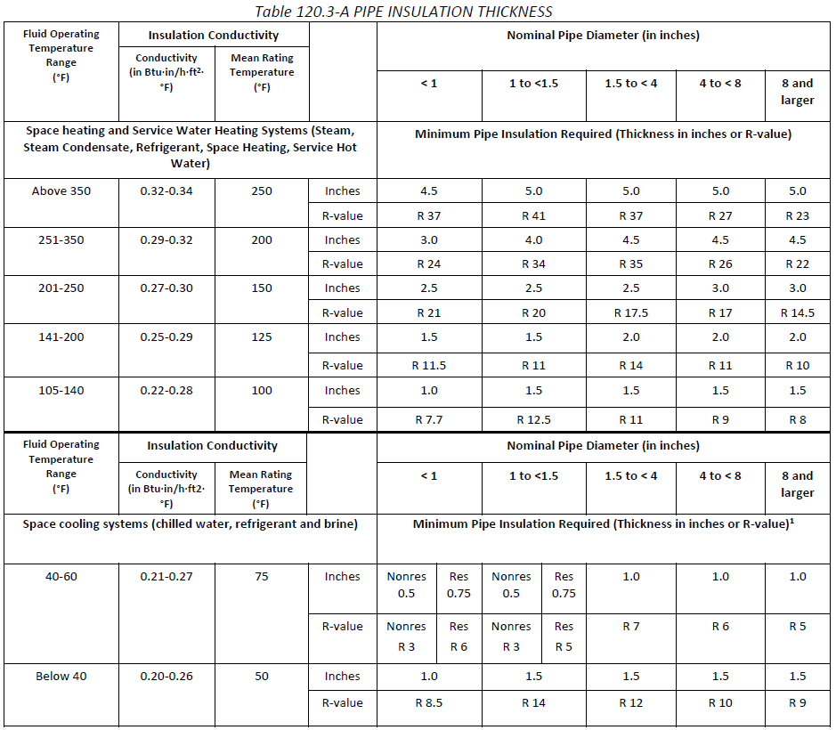


G. ACCEPTANCE TESTS & FIELD VERIFICATION
The following Acceptance Tests and HERS Verifications related to the systems or materials documented on this Certificate of Installation have been indicated on the permitted Certificate of Compliance as being required to comply with Title 24, Part 6.
Form/Title | Systems to be Field Verified
Certificates of Acceptance
Mechanical Acceptance Tests must be completed by a certified Acceptance Testing Technician and Certificate of Acceptance forms completed through an approved Acceptance Test Technician Certification Provider database. The Certificate of Acceptance forms indicated below will be required by the Authority Having Jurisdiction to demonstrate compliance.
NRCA-MCH-02-A Outdoor Air must be submitted for all newly installed HVAC units.
Note: MCH-02-A can be performed in conjunction with MCH-07-A Supply Fan VFD Acceptance (if applicable) since testing activities overlap.
NRCA-MCH-03-A - Must be submitted for Constant Volume Single Zone HVAC.
NRCA-MCH-04b-A - Must be submitted for Air Distribution Duct Leakage.
NRCA-MCH-05-A - Must be submitted for Air Economizer Controls.
NRCA-MCH-06-A - Must be submitted for Demand Control Ventilation.
NRCA-MCH-07-A - Must be submitted for Supply Fan Variable Flow Controls.
NRCA-MCH-08-A - Must be submitted for Valve Leakage Test.
NRCA-MCH-09-A - Must be submitted for Supply Water Temperature Reset Controls.
NRCA-MCH-10-A - Must be submitted for Hydronic System Variable Flow Controls.
NRCA-MCH-11-A - Must be submitted for Automatic Demand Shed Controls.
NRCA-MCH-12-A-FDD-F - Must be submitted for Packaged Direct Expansion Units.
NRCA-MCH-13-A-FDD - Must be submitted for Air Handling Units and Zone Terminal Units.
NRCA-MCH-14-A - Must be submitted for Distributed Energy Storage DX-AC Systems.
NRCA-MCH-15-A - Must be submitted for Thermal Energy Storage.
NRCA-MCH-16-A - Must be submitted for Supply Air Temperature Reset Controls.
NRCA-MCH-17-A - Must be submitted for Condenser Water.
NRCA-MCH-18-A - Must be submitted for Energy Management Control Systems.
NRCA-MCH-19-A - Must be submitted for Occupancy Sensor Controls.
NRCA-MCH-20-H - Must be submitted for Multifamily Ventilation.
NRCA-MCH-21-H - Must be submitted for Multifamily Envelope.
NRCA-MCH-22-A - Must be submitted for Multifamily Duct Leakage.
NRCA-MCH-23-A - Must be submitted for Multifamily HRV/ERV Verification.
Certificates of Verification
HERS verifications must be completed by a HERS Rater and NRCV forms completed through an approved HERS Provider database. The Certificate of Verification forms indicated below will be required by the Authority Having Jurisdiction to demonstrate compliance.
NRCA-MCH-04a-H - Must be completed by installer and submitted for Air Distribution Duct Leakage.
NRCV-MCH-04-H Duct Leakage Test
NRCV-MCH-24 Enclosure Air Leakage Worksheet
NRCV-MCH-27 High-rise Residential
NRCV-MCH-32 Local Mechanical Exhaust
There are no Acceptance Tests or HERS verifications indicated on the permitted Certificate of Compliance related to the systems or materials documented on this Certificate of Installation.
A copy of this Certificate of Installation should be distributed to the certified Acceptance Test Technician(s) who will perform the acceptance test(s). Title 24, Part 6 Section 10-103(a)3F also requires this Certificate of Installation be posted or made available to the Authority Having Jurisdiction for all applicable inspections.

Documentation Author's Declaration Statement
- I certify that this Certificate of Compliance documentation is accurate and complete.
Documentation Author Name: | Documentation Author Signature:
Company: | Signature Date:
Address: | CEA/HERS Certification Identification (if applicable):
City/State/Zip: | Phone:
Responsible Person's Declaration statement

I certify the following under penalty of perjury, under the laws of the State of California:
- The information provided on this Certificate of Compliance is true and correct.
- I am eligible under Division 3 of the Business and Professions Code to accept responsibility for the building design or system design identified on this Certificate of Compliance (responsible designer).
- The energy features and performance specifications, materials, components, and manufactured devices for the building design or system design identified on this Certificate of Compliance conform to the requirements of Title 24, Part 1 and Part 6 of the California Code of Regulations.
- The building design features or system design features identified on this Certificate of Compliance are consistent with the information provided on other applicable compliance documents, worksheets, calculations, plans and specifications submitted to the enforcement agency for approval with this building permit application.
- I will ensure that a completed signed copy of this Certificate of Compliance shall be made available with the building permit(s) issued for the building, and made available to the enforcement agency for all applicable inspections. I understand that a completed signed copy of this Certificate of Compliance is required to be included with the documentation the builder provides to the building owner at occupancy.
Responsible Designer Name: | Responsible Designer Signature:
Company : | Date Signed:
Address: | License:
City/State/Zip: | Phone:

A. General Information
- This field is filled out automatically.
- Enter the zip code of the construction project.
- Enter the Date of Permit Set used for construction.
- Enter the Name of Permit Set used for construction.
- Enter the Authority Having Jurisdiction.
- Enter the Building Permit #.
- Enter the Date of As-Built Set.
- Enter the Name of As-Built Set.
B. Project Scope
- Select all applicable equipment, systems and materials documented.
C. Compliance Results
Results in this table are automatically calculated from data input and calculations in Tables F.

D. Exceptional Conditions
- This table is auto filled with uneditable comments because of selections made or data entered in tables throughout the form.

E. Installer Notes
- Enter any notes or comments for the AHJ.

F. INSTALLATION DETAILS

Dry System Equipment Schedule
- This field is filled out automatically.
- Enter the model # of the equipment being installed.
- Select: True or False.
- Enter the heating mode Rated Output of the equipment in kBtu/h.
- Enter the Supplemental Heating Output of the equipment in kBtu/h.
- Enter the efficiency of the equipment while in heating mode.
- This field is filled out automatically.
- Enter the cooling mode Rated Output of the equipment in kBtu/h.
- Enter the efficiency of the equipment while in cooling mode.
- This field is filled out automatically.
- If a second efficiency is required, enter the efficiency of the equipment while in cooling mode.
- This field is filled out automatically.
- This field is calculated automatically.

Heat Pump Equipment Schedule
- This field is filled out automatically.
- Enter the model # of the equipment being installed.
- Select: True or False.
- Select: True or False.
- Enter the efficiency of the heat pump while in heating mode.
- This field is filled out automatically.
- Select: True or False.
- Select: True or False.
- Enter the efficiency of the heat pump while in cooling mode.
- This field is filled out automatically.
- If a second efficiency is required, enter the efficiency of the heat pump while in cooling mode.
- This field is filled out automatically.
- This field is calculated automatically.
DX DOAS Schedule
- This field is filled out automatically.
- Enter the model # of the equipment being installed.
- Select: True or False.
- Select: True or False.
- Select: True or False.
- Enter the ISMRE efficiency of the DOAS equipment.
- This field is static text showing the efficiency unit is ISMRE.
- Enter the ISCOP efficiency of the DOAS equipment.
- This field is static text showing the efficiency unit is ISCOP.
- This field is calculated automatically.
Boiler
- This field is filled out automatically.
- Enter the model # of the equipment being installed.
- Select: True or False.
- Enter the quantity of identical equipment being installed.
- Enter the Rated Input of the boiler in Btu/h.
- Enter the Rated Efficiency of the equipment.
- This field is automatically filled out.
- Isolation Valve: Select from Dropdown.
- Temperature Reset Controls: Select from Dropdown.
- This field is calculated automatically.
Chiller
- This field is filled out automatically.
- Enter the model # of the equipment being installed.
- Select: True or False.
- Enter the quantity of identical equipment being installed.
- Select: True or False.
- Enter the efficiency while in cooling mode.
- This field is filled out automatically.
- If a second efficiency is required, enter the efficiency while in cooling mode.
- This field is filled out automatically.
- Isolation Valve: Select from Dropdown.
- Temperature Reset Controls: Select from Dropdown.
- This field is calculated automatically.
Heat Rejection Equipment (Cooling Towers, Condensers, Waterside Economizers) Efficiency and Controls
- This field is filled out automatically.
- Enter the model # of the equipment being installed.
- Select: True or False
- Enter the quantity of identical equipment being installed.
- Enter the Rated Performance of the equipment being installed.
- This field is filled out automatically.
- Fan Speed Control: Select from Dropdown.
- Tower Flow Turndown: Select from Dropdown.
- Fan Control in Multiple Cell Equipment: Select from Dropdown.
- Economizer Control: Select from Dropdown.
- Condenser Water Temperature Reset: Select from Dropdown.
- This field is calculated automatically.
Electric Resistance Heating
- This field is filled out automatically.
- Enter the model # of the equipment being installed.
- This field is filled out automatically.
- Enter the Output Capacity in kW.
- This field is calculated automatically.
Pumps
- This field is filled out automatically.
- This field is filled out automatically.
- Enter the quantity of identical equipment being installed.
- Enter the Horsepower of the pump.
- Variable Flow Controls: Select from Dropdown.
- Hydronic Heat Pump Isolation Control: Select from Dropdown.
- Variable Speed Drive on pumps greater than 5 horsepower: Select from Dropdown.
- Differential Pressure Sensor Control: Select from Dropdown.
- This field is calculated automatically.
Fans and Air Economizers
- This field is filled out automatically.
- Enter the quantity of identical equipment being installed.
- Fan Function: Select from Dropdown.
- Economizer: Select from Dropdown.
- Enter the Electrical Input Power of the fan in Watts.
- This field is calculated automatically.
Dedicated Outdoor Air Systems (DOAS)
- This field is filled out automatically.
- Enter the quantity of identical equipment being installed.
- Delivered Directly to the Space: Select from Dropdown.
- Enter the fan system power in kilowatts.
- Enter the fan system airflow in cubic feet per minute.
- This field is calculated automatically.
- This field is static text that says less than or equal to 3 speeds.
- Multizone DOAS with cooling: Select from Dropdown.
- Select: Yes or No.
- Multifamily DOAS: Select from Dropdown.
- This field is calculated automatically.
System Controls
- This field is filled out automatically.
- Thermostat Controls: Select from Dropdown.
- Shut-off Controls: Select from Dropdown.
- Isolation Zone Controls: Select from Dropdown.
- Demand Response Controls: Select from Dropdown.
- Supply Air Temperature Reset Controls: Select from Dropdown.
- Window Interlock Controls: Select from Dropdown.
- Direct Digital Controls: Select from Dropdown.
- This field is calculated automatically.
Nonresidential, Hotel/Motel and Multifamily Common User Ventilation Systems
- This field is filled out automatically.
- Enter System Designed Outside Air Airflow in cubic feet per minute.
- Enter System Designed Transfer Air Airflow in cubic feet per minute.
- Air Filtration: Select from Dropdown.
- This field is filled out automatically.
- Enter Exhaust Ventilation for the space.
- Occupant Sensor Controls: Select from Dropdown.
- Demand Control Ventilation: Select from Dropdown.
- This field is calculated automatically.

Multifamily Dwelling Unit Ventilation Systems
- This field is filled out automatically.
- Enter System Designed Outside Air Airflow in cubic feet per minute.
- Enter System Designed Supply Air Airflow in cubic feet per minute.
- Enter Exhaust Air Airflow in cubic feet per minute.
- Local Exhaust: Select from Dropdown.
- Air Filtration: Select from Dropdown.
- This field is calculated automatically.
Terminal Box Controls
- This field is filled out automatically.
- Zonal Control Strategy: Select from Dropdown.
- Enter the Peak Primary Airflow for the zone or system in cubic feet per minute.
- Enter the Primary Air in Deadband Airflow for the zone or system in cubic feet per minute.
- Enter the Reheated, Recooled or Mixed Airflow for the zone or system in cubic feet per minute.
- Enter the Outside Air Airflow for the zone or system in cubic feet per minute.
- Confirm the first stage modulates and maintains the drybulb rate.
- Confirm the second stage modulates from drybulb flow to heating max flow.
- This field is calculated automatically.
Ducts
- This field is filled out automatically.
Pipe Insulation
- This table includes required pipe insulation values from Part 6 and does not require user entry.
G. Acceptance Tests and Field Verification
- This field is filled out automatically.

